

**SUMMER EXAMINATIONS 2017**

**EXAMINATION:**

**UNIT 3 Packaging Materials and Containers 2**

**COURSE:**

**CPD Diploma in Packaging Technology**

**DATE:**

**11th May 2017**

**10am to 12pm**

**EXAMINERS: Colm Munnelly, Tony Duffy, Ron Gardiner**

**TIME ALLOWED: 2 hours**

**INSTRUCTIONS: Please answer four questions. All questions carry equal marks**

**PLEASE DO NOT TURN OVER THIS PAGE UNTIL YOU ARE INSTRUCTED TO DO SO**

**The use of programmable or text storing calculators, smart phones etc are expressly forbidden. Please note that where a candidate answers more than the required number of questions, the examiner will mark all questions attempted and then select the highest scoring ones.**

**Unit 3** **Page 1 of 3**

**Question 1 (25 marks)**

**a)** **Describe the polymerisation of low density polyethylene (LDPE).**

**(9 marks)**

1. **Briefly describe two other polymerisation processes and give an example of a material made from each**

**(6 marks)**

1. **Explain the following terms as applied to polymer characteristics.**
   1. **Polymer chain branching**
   2. **Crystallinity**
   3. **Orientation**
   4. **Copolymer**
   5. **Thermoplastic**

**(10 marks, 5 X 2 marks)**

**Question 2 (25 marks)**

1. **Select and justify an appropriate plastic material or combination of plastic materials and manufacturing method for the packaging for the following products.**
   1. **Vacuum bag for large meat cut.**
   2. **Carbonated soft drink**
   3. **1 litre of fresh milk**
   4. **Flip top closure for shampoo bottle**
   5. **Oven ready meal tray (Heated at 220oC)**

**(15 marks, 5 x 3 marks)**

1. **Identify 5 different additivities which can be added to plastics. For what applications would their use be appropriate**

**(10 marks, 5 x 2 marks)**

**Question 3 (25 marks)**

1. **Laminates are often used in packaging applications. Briefly describe 3 examples of laminates being used in packaging. For each example identify the function of each layer within its structure.**

**(15 marks, 3 X 5 marks)**

**b) Briefly describe three different methods for combining materials.**

**(10 marks)**

**Unit 3** **Page 2 of**

**Question 4 (25 marks)**

1. **Describe, with the aid of a diagram where appropriate, the production of a polypropylene sheet which may be used for thermoforming trays. Start with polymer granules and end with the reeled sheet material.**

**(15 marks)**

**b) Describe how this sheet can be thermoformed into a tray.**

**c)Discuss how the thermoforming process alters material thickness and propertie**

**(5marks)**

**Question 5 (25 marks)**

**Consider a glass bottle for Carlsberg.**

**a)** **Describe the application of a paper label to this bottle**

**(10 marks)**

**b)** **Justify a suitable glue for this application process**

**(5 marks)**

1. **Why is it important to control the Machine Direction and Cross Direction of the Label**

**(3 marks)**

**d) Name two other methods of labelling this bottle**

**(2 marks)**

**e) Briefly review material considerations you should review with your label supplier**

**(5 marks)**

**Unit 3** **Page 3 of 3**

**Question 1 (25 marks)**

**a) Describe the polymerisation of low density polyethylene (LDPE).**

**(9 marks)**

The polymerization of low-density polyethylene (LDPE) is a process by which ethylene monomers are polymerized to form long-chain polyethylene molecules. LDPE is a thermoplastic polymer known for its flexibility, toughness, and chemical resistance. The polymerization of LDPE typically occurs through a process called radical polymerization, which involves the following steps:

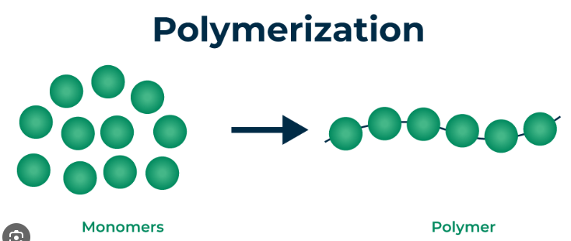

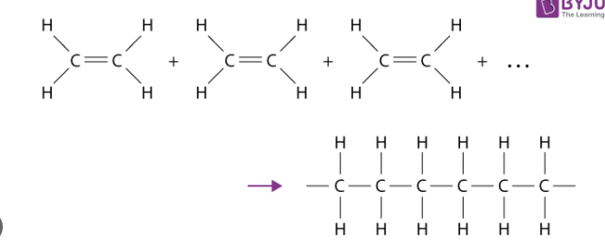

1. **Briefly describe two other polymerisation processes and give an example of a material made from each**

**(6 marks)**

Two other polymerization processes are condensation polymerization and addition polymerization:

1. **Condensation Polymerization:**

- **Description:** Condensation polymerization involves the reaction of monomers with the elimination of small molecules like water, alcohol, or hydrogen chloride.

- **Example Material:** Nylon-6,6 is a material made through condensation polymerization. It is a type of polyamide used in textiles, carpets, and engineering plastics.

2. **Addition Polymerization:**

- **Description:** Addition polymerization involves the repeated addition of unsaturated monomers to form a polymer chain without the formation of by-products.

- **Example Material:** Polyethylene terephthalate (PET) is a material made through addition polymerization. It is commonly used in beverage bottles, food packaging, and synthetic fibers like polyester.

1. **Explain the following terms as applied to polymer characteristics.**
   1. **Polymer chain branching**
   2. **Crystallinity**
   3. **Orientation**
   4. **Copolymer**
   5. **Thermoplastic**

**(10 marks, 5 X 2 marks)**

Here are the explanations for the terms as applied to polymer characteristics:

1. **Polymer Chain Branching:**

- **Explanation:** Polymer chain branching refers to the presence of side chains or branches along the main polymer chain. These branches can affect the physical properties of the polymer, such as flexibility, strength, and crystallinity.

2. **Crystallinity:**

- **Explanation:** Crystallinity in polymers refers to the degree of molecular order within the polymer chains. Highly crystalline polymers have well-organized molecular structures, leading to increased stiffness and strength, while amorphous polymers lack this order and are more flexible.

3. **Orientation:**

- **Explanation:** Orientation in polymers refers to the alignment of polymer chains in a specific direction. This alignment can occur during processing or stretching, leading to enhanced mechanical properties in the oriented direction.

4. **Copolymer:**

- **Explanation:** A copolymer is a polymer formed by the polymerization of two or more different monomers. Copolymers combine the properties of the individual monomers, allowing for the customization of polymer properties such as flexibility, strength, and chemical resistance.

5. **Thermoplastic:**

- **Explanation:** Thermoplastics are a type of polymer that can be melted and reshaped multiple times without undergoing chemical degradation. They soften when heated and solidify when cooled, making them suitable for processes like injection molding and extrusion.

**Question 2 (25 marks)**

1. **Select and justify an appropriate plastic material or combination of plastic materials and manufacturing method for the packaging for the following products.**
   1. **Vacuum bag for large meat cut.**
   2. **Carbonated soft drink**
   3. **1 litre of fresh milk**
   4. **Flip top closure for shampoo bottle**
   5. **Oven ready meal tray (Heated at 220oC)**

**(15 marks, 5 x 3 marks)**

For the packaging of the following products, the appropriate plastic material or combination of plastic materials and manufacturing methods are as follows:

1. **Vacuum Bag for Large Meat Cut:**

- **Plastic Material:** Polyethylene (PE) or Polyethylene terephthalate (PET) are suitable choices for vacuum bags due to their excellent barrier properties against oxygen and moisture.

- **Manufacturing Method:** The bags can be manufactured using extrusion processes to create airtight seals and ensure the necessary barrier properties for vacuum packaging.

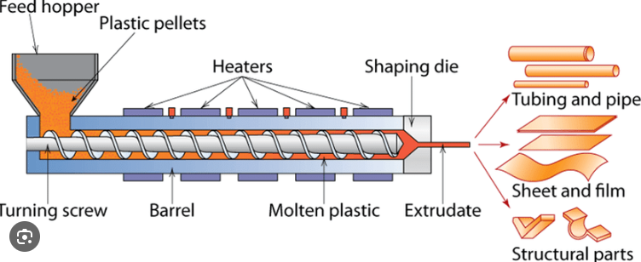

2. **Carbonated Soft Drink:**

- **Plastic Material:** Polyethylene terephthalate (PET) is commonly used for carbonated soft drink bottles due to its strength, transparency, and ability to withstand the pressure from carbonation.

- **Manufacturing Method:** The bottles are typically manufactured using the stretch blow molding process to create lightweight, durable containers suitable for carbonated beverages.

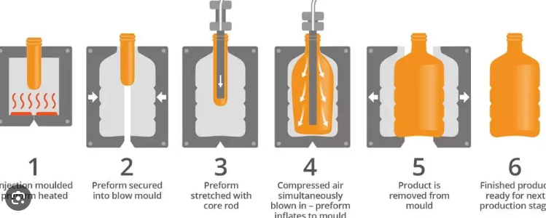

3. **1 Litre of Fresh Milk:**

- **Plastic Material:** High-Density Polyethylene (HDPE) is a suitable choice for fresh milk packaging due to its excellent chemical resistance and ability to protect the milk from light and oxygen.

- **Manufacturing Method:** The milk bottles can be produced using blow molding techniques to create sturdy containers that preserve the freshness and quality of the milk.

4. **Flip Top Closure for Shampoo Bottle:**

- **Plastic Material:** Polypropylene (PP) is a common choice for flip-top closures due to its durability, chemical resistance, and ease of molding for intricate designs.

- **Manufacturing Method:** Injection molding is typically used to manufacture flip-top closures, allowing for precise molding of the closure components.

5. **Oven-Ready Meal Tray (Heated at 220°C):**

- **Plastic Material:** Polypropylene (PP) or Polyethylene terephthalate (PET) are suitable for oven-ready meal trays as they can withstand high temperatures without deforming or releasing harmful chemicals.

- **Manufacturing Method:** Thermoforming is a suitable manufacturing method for producing oven-ready meal trays, allowing for the creation of trays with specific shapes and properties required for heating at high temperatures.

1. **Identify 5 different additivities which can be added to plastics. For what applications would their use be appropriate**

**(10 marks, 5 x 2 marks)**

Here are five different additives commonly added to plastics and their appropriate applications:

1. **UV Stabilizers:**

- **Application:** Outdoor applications such as agricultural films, automotive components, construction materials, and outdoor furniture.

- **Purpose:** UV stabilizers protect plastics from degradation caused by exposure to ultraviolet (UV) radiation from sunlight, thereby extending their lifespan and preserving their mechanical properties.

2. **Antioxidants:**

- **Application:** Packaging materials, automotive parts, electrical insulation, and consumer goods.

- **Purpose:** Antioxidants prevent the degradation of plastics due to exposure to oxygen, heat, and light. They help maintain the physical and mechanical properties of plastics, such as strength, flexibility, and appearance.

3. **Flame Retardants:**

- **Application:** Building materials, electronics, automotive components, and textiles.

- **Purpose:** Flame retardants reduce the flammability of plastics and inhibit the spread of fire, thereby improving fire safety in various applications where fire resistance is critical.

4. **Plasticizers:**

- **Application:** Flexible PVC products such as cables, hoses, flooring, and medical devices.

- **Purpose:** Plasticizers improve the flexibility, softness, and workability of plastics, particularly PVC, by increasing their elongation at break and reducing their glass transition temperature. They are essential for formulating flexible and durable plastic products.

5. **Colorants and Pigments:**

- **Application:** Packaging materials, consumer products, toys, and automotive components.

- **Purpose:** Colorants and pigments enhance the visual appeal of plastics by imparting color and opacity to the material. They are used to achieve specific aesthetic effects and brand identification in various plastic products.

These additives play crucial roles in enhancing the performance, durability, aesthetics, and safety of plastics in a wide range of applications, ensuring that plastic products meet the diverse needs and requirements of end-users while maintaining quality and functionality over time.

**Question 3 (25 marks)**

1. **Laminates are often used in packaging applications. Briefly describe 3 examples of laminates being used in packaging. For each example identify the function of each layer within its structure.**

**(15 marks, 3 X 5 marks)**

Based on the information provided in the search results, here are three examples of laminates used in packaging applications, along with the function of each layer within the laminate structure:

1. **Flexible Packaging Laminate for Snack Bags:**

- Outer Layer: Oriented Polypropylene (OPP) or Polyester (PET) - Provides strength, printability, and aesthetic appeal.

- Middle Layer: Aluminum Foil - Offers excellent barrier properties against oxygen, moisture, and light, helping to preserve the freshness and quality of the snack product.

- Inner Layer: Polyethylene (PE) - Provides heat-sealing properties, allowing the bag to be hermetically sealed to maintain the product's shelf life.

2. **Retort Pouch Laminate for Shelf-Stable Foods:**

- Outer Layer: Polyester (PET) - Offers strength, durability, and printability for branding and labeling.

- Middle Layer: Aluminum Foil - Provides an effective barrier against oxygen, moisture, and light, ensuring the long-term shelf stability of the packaged food.

- Inner Layer: Polypropylene (PP) or Polyethylene (PE) - Enables heat-sealing of the pouch and compatibility with the high-temperature retort process.

3. **Beverage Carton Laminate:**

- Outer Layer: Polyethylene (PE) - Provides a smooth, printable surface for branding and graphics.

- Middle Layer: Paperboard - Offers structural integrity and rigidity to the carton.

- Inner Layer: Polyethylene (PE) - Creates a barrier against liquids, gases, and contaminants, protecting the beverage inside.

In each of these examples, the laminate structure combines different materials, each serving a specific function to meet the packaging requirements, such as barrier properties, strength, sealability, and aesthetics, for the respective food or beverage products.

**b) Briefly describe three different methods for combining materials.**

**(10 marks)**

Based on the information provided in the search results, here are three different methods for combining materials in packaging:

1. **Film Lamination by Adhesive:**

- Description: This method involves bonding two or more plastic films together using an adhesive. The adhesive is applied between the film layers, which are then pressed together to create a laminated structure.

- Example: Laminating a metallized polyester film to a polyethylene film to create a high-barrier packaging material for food or pharmaceutical products.

2. **Extrusion Lamination:**

- Description: In this process, a molten plastic is extruded and pressed onto a pre-existing web or film, creating a laminated structure. The heat and pressure from the extrusion process bond the layers together.

- Example: Extruding a layer of polyethylene onto a paper or aluminum foil substrate to create a laminated material for packaging applications.

3. **Thermal Lamination:**

- Description: Thermal lamination uses heat and pressure to bond two or more plastic films together without the use of an adhesive. The films are passed through heated rollers, which melt the surfaces and fuse the layers together.

- Example: Laminating a polyester film to a polyethylene film to create a high-strength, heat-sealable packaging material.

These three methods allow for the combination of different materials, such as plastics, paper, and foils, to create composite packaging structures with enhanced properties, such as improved barrier, strength, or sealability, compared to using a single material alone.

**Question 4 (25 marks)**

1. **Describe, with the aid of a diagram where appropriate, the production of a polypropylene sheet which may be used for thermoforming trays. Start with polymer granules and end with the reeled sheet material.**

**(15 marks)**

**b) Describe how this sheet can be thermoformed into a tray.**

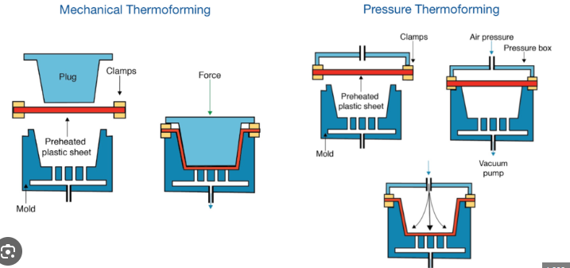

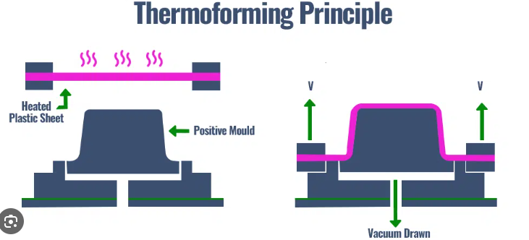

**c)Discuss how the thermoforming process alters material thickness and propertie**

The thermoforming process involves heating a thermoplastic sheet until it becomes pliable, then forming it into a specific shape using a mold and cooling it to set the shape. During thermoforming, the material thickness and properties can be altered in the following ways:

1. **Material Thickness:**

- **Stretching:** Thermoforming can stretch the material to conform to the shape of the mold, which can lead to thinning of the material in certain areas, especially in deep draw or complex shapes.

- **Uniformity:** The thickness of the material can be controlled by adjusting the heating and forming parameters to ensure uniform distribution of material thickness across the formed part.

2. **Material Properties:**

- **Orientation:** Thermoforming can induce molecular orientation in the material, affecting its mechanical properties. The stretching and cooling process can align polymer chains, increasing stiffness and strength in certain directions.

- **Impact Resistance:** Thermoforming can impact the impact resistance of the material. Thinner areas may have reduced impact resistance compared to thicker sections due to material stretching and thinning during forming.

- **Surface Finish:** The thermoforming process can affect the surface finish of the material. The mold surface and forming conditions can influence the gloss, texture, and appearance of the final formed part.

In summary, the thermoforming process can alter material thickness and properties through stretching, orientation, impact resistance, and surface finish adjustments. Proper control of heating, forming parameters, and mold design is essential to achieve the desired thickness distribution and material properties in thermoformed parts.

**Question 5 (25 marks)**

**Consider a glass bottle for Carlsberg.**

**a) Describe the application of a paper label to this bottle**

**(10 marks)**

Based on the information provided in the search results, here is a description of the application of a paper label to a glass bottle for Carlsberg:

1. Label Material:

- The label for the Carlsberg glass bottle is typically made of paper, which provides a suitable surface for printing graphics, text, and branding elements.

2. Label Application:

- The paper label is applied to the glass bottle using an adhesive, which can be a water-based or solvent-based adhesive depending on the specific requirements.

- The label is carefully positioned and adhered to the curved surface of the glass bottle, ensuring a smooth and wrinkle-free application.

3. Label Design:

- The paper label is designed with the Carlsberg branding, including the logo, color scheme, and any other relevant information or graphics.

- The label design is often eye-catching and visually appealing to attract consumers and reinforce the Carlsberg brand identity.

4. Label Benefits:

- The paper label provides a versatile surface for printing high-quality graphics and information, allowing Carlsberg to effectively communicate its brand messaging.

- The label can also serve as a platform for promotional elements, such as limited-edition designs or special offers.

- The paper material allows for a range of finishing options, such as matte or glossy coatings, embossing, or foil stamping, to enhance the visual appeal and tactile experience of the Carlsberg bottle.

Overall, the application of a paper label to the Carlsberg glass bottle helps to create a distinctive and recognizable product, reinforcing the brand's identity and appeal to consumers.

**b) Justify a suitable glue for this application process**

**(5 marks)**

For the application of paper labels to Carlsberg glass bottles, a suitable glue should possess several key characteristics to ensure proper adhesion, durability, and compatibility with the labeling process. Here's a justification for selecting a specific type of glue:

1. **Adhesion Strength:** The glue should provide strong adhesion to both the paper label and the glass surface of the bottle to prevent label detachment during handling, transportation, and storage.

2. **Quick Drying:** A fast-drying adhesive is desirable to optimize production efficiency and minimize downtime between label application and subsequent packaging steps.

3. **Moisture Resistance:** The glue should be resistant to moisture to maintain label adhesion and prevent label wrinkling or peeling in humid or wet conditions, such as during refrigeration or ice bucket immersion.

4. **Temperature Resistance:** The adhesive should withstand temperature variations encountered during the bottling process, including heat from the label application equipment and potential exposure to cold temperatures during refrigeration or storage.

5. **Non-Toxicity:** As the labels are applied to beverage bottles, the adhesive must be non-toxic and food-safe to ensure compliance with regulatory standards and consumer safety requirements.

6. **Compatibility with Printing Inks:** The glue should be compatible with the printing inks used on the paper labels to prevent ink bleeding, smudging, or discoloration, which could compromise label appearance and brand presentation.

7. **Easy Removability:** While strong adhesion is necessary for label security, the glue should allow for easy removal of labels during recycling or bottle reuse processes without leaving behind residue or damaging the bottle surface.

Based on these criteria, a suitable adhesive for the application of paper labels to Carlsberg glass bottles is a water-based acrylic adhesive. Here's why:

- **Water-Based Acrylic Adhesive:** Water-based acrylic adhesives offer excellent adhesion to both paper and glass surfaces, providing strong initial tack and long-term bond strength.

- **Quick-Drying:** Water-based acrylic adhesives typically have a fast-drying formulation, allowing for rapid label application and efficient production throughput.

- **Moisture and Temperature Resistance:** Acrylic adhesives exhibit good resistance to moisture and temperature fluctuations, ensuring label adhesion integrity in various environmental conditions.

- **Non-Toxic and Food-Safe:** Water-based acrylic adhesives are non-toxic and FDA-approved for indirect food contact, making them safe for use in beverage packaging applications.

- **Compatibility with Printing Inks:** Acrylic adhesives are compatible with a wide range of printing inks, including solvent-based and water-based inks, ensuring compatibility with the printing process used for Carlsberg labels.

- **Easy Removability:** Acrylic adhesives can be formulated to provide sufficient bond strength for label security while allowing for clean and easy removal of labels without residue or damage to the bottle surface.

Overall, a water-based acrylic adhesive meets the specific requirements of label application to Carlsberg glass bottles, providing strong adhesion, durability, and compatibility with the labeling process while ensuring consumer safety and product quality.

1. **Why is it important to control the Machine Direction and Cross Direction of the Label**

**(3 marks)**

**d) Name two other methods of labelling this bottle**

**(2 marks)**

In addition to using glue-applied paper labels, Carlsberg glass bottles can be labeled using the following methods:

1. **Pressure-Sensitive Labels (PSL):**

- Pressure-sensitive labels, also known as self-adhesive labels, are pre-printed labels with an adhesive backing that adheres to the surface of the bottle when pressure is applied. PSLs are versatile and can be applied manually or using automated labeling equipment. They offer flexibility in label design, material options, and finishing effects such as gloss or matte coatings. Pressure-sensitive labels are commonly used for premium branding and high-quality graphics, offering excellent visual appeal and product differentiation.

2. **Shrink Sleeve Labels:**

- Shrink sleeve labels are pre-printed labels made from shrinkable plastic film materials such as PVC, PETG, or OPS (oriented polystyrene). These labels are applied to the bottle by inserting the bottle into a heat tunnel, which shrinks the label tightly around the bottle's contour, conforming to its shape. Shrink sleeve labels provide full-wrap coverage, allowing for 360-degree branding and graphics. They offer tamper-evident features and can accommodate complex bottle shapes and curves. Shrink sleeve labels are commonly used for product branding, promotional campaigns, and limited edition packaging due to their vibrant graphics and visual impact.

Both pressure-sensitive labels and shrink sleeve labels offer advantages in terms of application flexibility, design options, and visual appeal, making them suitable alternatives for labeling Carlsberg glass bottles alongside traditional glue-applied paper labels.

**e) Briefly review material considerations you should review with your label supplier**

**(5 marks)**